## Emmeans alternative to lsmeans – with modifications PP75, FM2.5

### Supplementation Experiment

Niki: “Can’t use cumberland pass (no supplement seeds were successfully collected…triple checking that). Marginal interaction effect: total seeds per plant increased with supplementation of skunky, but not sweet, flowers. Sweet has this weird relationship where sup seedset goes up with flower size. Jake swears size differences shouldn’t have influenced the effectiveness of the treatment.”

#### Sweet morph only

Niki: “no effect of habitat => remove no treatment effect, but Candi saw this in some years - might it relate to weaking selection?”

Niki: “Extract least squares mean which accounts for random effect”

fit<-lme(sqrt(Total.SeedsPerPlant)~Treatment, random=~1|Site, data=fruit.sw.np, method="ML", na.action=na.omit)   
anova.lme(fit)

## numDF denDF F-value p-value  
## (Intercept) 1 28 199.11010 <.0001  
## Treatment 1 28 0.27848 0.6019

#type="response" causes the emmeans and contrasts tables to backtransform from the sqrt and show confidence intervals and p-values that represent the backtransformed variables  
marginal = emmeans(fit, specs=pairwise ~ Treatment, type = "response")  
marginal$emmeans

## Treatment response SE df lower.CL upper.CL  
## Natural 44.1 7.25 1 0 184  
## Supplementation 37.3 10.43 1 0 287  
##   
## d.f. method: containment   
## Confidence level used: 0.95   
## Intervals are back-transformed from the sqrt scale

marginal$contrasts

## contrast estimate SE df t.ratio p.value  
## Natural - Supplementation 0.535 1.01 28 0.528 0.6019

marginal$contrasts %>%  
 summary(infer = TRUE)

## contrast estimate SE df lower.CL upper.CL t.ratio  
## Natural - Supplementation 0.535 1.01 28 -1.54 2.61 0.528   
## p.value  
## 0.6019   
##   
## Confidence level used: 0.95

#putting the data into a data frame so that we can plot it  
marginal_contrasts = marginal$contrasts %>%  
 summary() %>%  
 as.data.frame()  
marginal_contrasts

## contrast estimate SE df t.ratio p.value  
## 1 Natural - Supplementation 0.5345919 1.013029 28 0.5277162 0.6018536

marginal_sqrt = emmeans(fit, specs=pairwise ~ Treatment)  
#plot of the sqrt transformed emmeans  
plot(marginal_sqrt, xlab="Estimated marginal means")

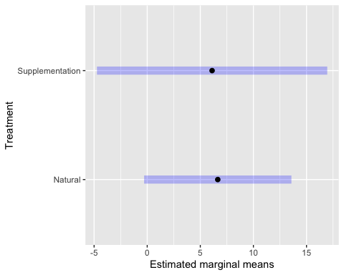

Plots (not controlling for random effects)

ggplot(fruit.sw.np, aes(Treatment,Total.SeedsPerPlant)) +  
 geom_violin(fill='gray') +  
 geom_dotplot(binaxis='y', stackdir='center', dotsize=1) +  
 facet_wrap(~Morph) +  
 scale_y_continuous(trans="sqrt") +  
 ylab("Seeds per plant") +  
 xlab("Morph") +  
 theme_bw() +  
 theme(panel.grid.major = element_blank(), panel.grid.minor = element_blank(), text = element_text(size=18))

## `stat_bindot()` using `bins = 30`. Pick better value with `binwidth`.

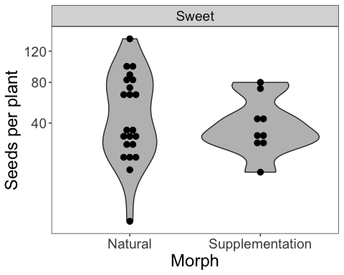

ggplot(fruit.sw.np, aes(Treatment,Total.SeedsPerPlant)) +  
 geom_boxplot() +   
 scale_y_continuous(trans="sqrt") +  
 ylab("Seeds per plant") +  
 xlab("Morph") +  
 theme_bw() +  
 theme(panel.grid.major = element_blank(), panel.grid.minor = element_blank(), text = element_text(size=18))

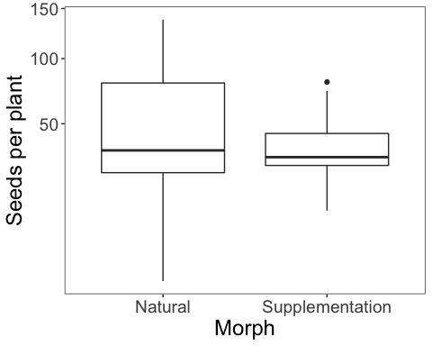

With habitat effects: Val: “For the two second ANOVA tables, I am getting an error regarding the use of lm() instead of lme() - why are we using lm() and why is it not computing into an ANOVA table?”

fit<-lme(sqrt(Total.SeedsPerPlant)~Treatment, random=~1|Site/Habitat, data=fruit.sw.np, method="ML", na.action=na.omit)   
anova.lme(fit)

## numDF denDF F-value p-value  
## (Intercept) 1 26 166.63119 <.0001  
## Treatment 1 26 0.33518 0.5676

fit<-lm(sqrt(Total.SeedsPerPlant)~Habitat, data=fruit.sw.np)  
  
fit<-lme(sqrt(Total.SeedsPerPlant)~Treatment*Habitat, random=~1|Site, data=fruit.sw.np, method="ML", na.action=na.omit)   
anova.lme(fit)

## numDF denDF F-value p-value  
## (Intercept) 1 26 197.26667 <.0001  
## Treatment 1 26 0.27591 0.6038  
## Habitat 1 26 1.69895 0.2039  
## Treatment:Habitat 1 26 0.03256 0.8582

fit<-lm(sqrt(Total.SeedsPerPlant)~Site, data=fruit.sw.np)

Both Morphs

fit<-lme(sqrt(Total.SeedsPerPlant)~Treatment*Morph, random=~1|Site, data=fruit.np, method="ML", na.action=na.omit)   
anova.lme(fit)

## numDF denDF F-value p-value  
## (Intercept) 1 50 415.3788 <.0001  
## Treatment 1 50 0.4960 0.4845  
## Morph 1 50 0.1446 0.7053  
## Treatment:Morph 1 50 2.1199 0.1516

marginal_both = emmeans(fit, specs=pairwise ~ Treatment, type = "response")

## NOTE: Results may be misleading due to involvement in interactions

marginal_both$emmeans

## Treatment response SE df lower.CL upper.CL  
## Natural 40.9 5.40 1 1.06 138  
## Supplementation 47.0 7.44 1 0.00 189  
##   
## Results are averaged over the levels of: Morph   
## d.f. method: containment   
## Confidence level used: 0.95   
## Intervals are back-transformed from the sqrt scale

marginal_both$contrasts

## contrast estimate SE df t.ratio p.value  
## Natural - Supplementation -0.466 0.687 50 -0.678 0.5009   
##   
## Results are averaged over the levels of: Morph

marginal_both_sqrt = emmeans(fit, specs=pairwise ~ Treatment)

## NOTE: Results may be misleading due to involvement in interactions

marginal_both$contrasts %>%  
 summary(infer = TRUE)

## contrast estimate SE df lower.CL upper.CL t.ratio  
## Natural - Supplementation -0.466 0.687 50 -1.85 0.914 -0.678   
## p.value  
## 0.5009   
##   
## Results are averaged over the levels of: Morph   
## Confidence level used: 0.95

#putting the data into a data frame so that we can plot it  
marginal_contrasts2 = marginal_both$contrasts %>%  
 summary() %>%  
 as.data.frame()  
marginal_contrasts2

## contrast estimate SE df t.ratio p.value  
## 1 Natural - Supplementation -0.4658238 0.6870983 50 -0.677958 0.5009238

#plot of the sqrt transformed emmeans  
plot(marginal_both_sqrt, xlab="Estimated marginal means")

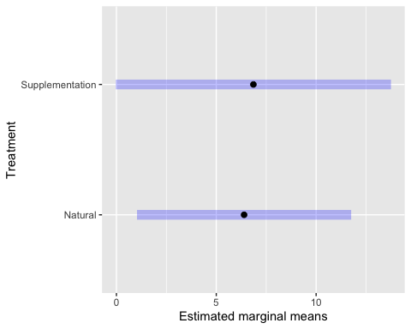

plot (not controlling for random effects)

ggplot(fruit.sm, aes(Treatment,Total.SeedsPerPlant)) +  
 geom_boxplot() +   
 scale_y_continuous(trans="sqrt") +  
 ylab("Seeds per plant") +  
 facet_wrap(~Morph) +  
 theme_bw() +  
 theme(panel.grid.major = element_blank(), panel.grid.minor = element_blank(), text = element_text(size=18))

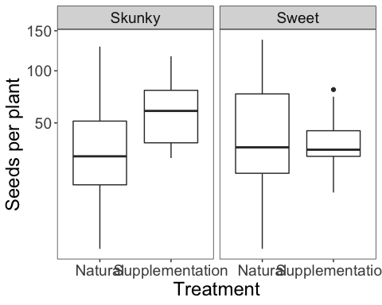

with habitat effects:

fit<-lme(sqrt(Total.SeedsPerPlant)~Treatment*Habitat, random=~1|Site, data=fruit.np, method="ML", na.action=na.omit)   
anova.lme(fit)

## numDF denDF F-value p-value  
## (Intercept) 1 50 411.6173 <.0001  
## Treatment 1 50 0.4915 0.4865  
## Habitat 1 50 0.5791 0.4502  
## Treatment:Habitat 1 50 1.2031 0.2780